Dependence of Knee Range of Motion on Posterior Tibial Slope after Medial Unicompartmental Knee Arthroplasty

Abstract
Background: Osteoarthritis (OA) is the most common joint disease and most frequent cause of chronic muscloskeletal pain. When conservative treatments fail, different types of surgical interventions for medial compartmental O.A. are valid including; high tibial osteotomy (HTO), unicompartmental knee arthroplasty (UKA) or total knee arthroplasty (TKA). The aim of this work was to assess the ability to achieve the anatomical posterior tibial slope in manual medial UKA and to asses effect of posterior tibial slope (PTS) on postoperative knee range of motion. Methods: This prospective randomized study was carried out on 40 patients with medial knee compartment osteoarthritis prospectively who were candidate for medial UKA at Benha University Hospitals. Patients were randomly divided into two equal groups; Group 1: patients preoperative anatomical tibial slope angle were tried to be achieved manually and group 2 where standard 7° angle PTS suggested by the manufacturer were used. All patients were subjected to general and musculoskeletal examination, laboratory investigations and radiological evaluation. Results: There was a significant positive correlation between postoperative PTS and postoperative range of motion (ROM) flexion (r=0.849, P<0.001) and postoperative functional score (r=0.375, P=0.017). There was a significant negative correlation between postoperative PTS and postoperative ROM extension (r=-0.737, P<0.001). Conclusions: Our study revealed that postoperative PTS was insignificantly different compared to preoperative PTS in group A proving that this approach couldn’t restore the preoperative value. There was a significant positive correlation between post-operative PTS with postoperative ROM flexion and functional score, a significant negative correlation with postoperative ROM extension.
Keywords: Knee; Range of Motion; Posterior Tibial Slope; Medial; Unicompartmental Knee Arthroplasty

Introduction
Osteoarthritis (OA) is the most common joint disease and most frequent cause of chronic muscloskeletal pain ^{[1]}. In 80-90% of cases, O.A. knee begins in medial compartment and tends to be unicompatmental ^{[2]}. When conservative treatments fail, different types of surgical interventions for medial compartmental O.A. are valid including; high tibial osteotomy (HTO), unicompartmental knee arthroplasty (UKA) or total knee arthroplasty (TKA). Many authors suggest HTO for younger more active patient and preserve arthroplasty for older patients ^{[3]}.
UKA has been increasingly used in clinical practice over the last decade ^{[4]}. For the treatment of end-stage medial compartment disease of the knee, it has the advantage of minimal invasiveness, less bleeding, less soft tissue injury, fast recovery and bone-stock conservation ^{[5]}. It has become a popular alternative to TKA, with great patient satisfaction and favorable functional outcomes, especially in younger patients ^{[6]}. The accurate positioning of the implant is a critical factor for implant longevity. A broad range of up to 20° for the posterior tibial slope (PTS) has been recommended by many researchers and manufacturers ^{[7]}, and the PTS may directly affect implant stability, postoperative joint mobility ^{[8]}.
The postoperative flexion angle is one of the most important factors for good, functional long-term survival rate results of arthroplasty ^{[9]}. It is essential to attain deep knee flexion in order to live a comfortable life. Securing the balance of the intraoperative soft tissue affects a wide range of motion (ROM) ^{[10, 11]}.
The PTS has been reported to influence the flexion gap in TKA ^{[12, 13]}. Actually, it has also been reported that the PTS was correlated to the postoperative ROM ^{[14]}. Although the role of the PTS has been discussed in the current literature on UKA, its role and recommended angle remain controversial ^{[8]}.
The aim of this work was to assess the ability to achieve the anatomical posterior tibial slope in manual medial UKA and to asses effect of PTS on postoperative knee range of motion.

Patients and Methods
This prospective randomized study was carried out on 40 patients with medial knee compartment osteoarthritis prospectively who were candidate for medial UKA at Benha University Hospitals, in the duration from May 2022 to May 2024. An informed written consent was obtained from the patients. The study was done after approval from the Ethics Committee of the Faculty of Medicine, Benha University (approval code: MD 8-4-2022).
Inclusion criteria were age ≥ 40 years old, both sexes, functionally intact anterior cruciate ligament (ACL) and posterior cruciate ligament (PCL), full thickness cartilage loss on anterior and middle parts of the medial compartment with bone on bone contact, normal cartilage thickness in lateral compartment and posterior part of medial compartment, MCL was not structurally shortened (passively correctable varus deformity <15°), patellofemoral joint damage limited to (or greater on) the medial facet and fixed flexion deformity < 15°.
Exclusion criteria were active infection, sepsis and osteomyelitis, inflammatory joint disease, metabolic disorders that impair bone formation, Charcot disease, vascular insufficiency, muscular atrophy, neuromuscular and cognitive disorders, revision of failed prosthesis, failed high tibial osteotomy (HTO), post traumatic arthritis after tibial plateau fracture, insufficiency of collateral or cruciate ligaments which could affect implant stability, full thickness damage of weight bearing area of lateral compartment, severe lateral PF OA with bone loss, grooving and eburnation, fixed varus deformity ˃ 15° (not passively correctable) and fixed flexion deformity ˃ 15° (not passively correctable).
Randomization:
40 patients were randomized into two groups at a ratio of 1:1. Opaque sealed envelopes containing sequential numbers were given to the study patients, according to which each patient was enrolled to one of the two groups:
Group 1 (N=20): patients preoperative anatomical tibial slope angle were tried to be achieved manually.
Group 2 (N=20): standard 7° angle PTS suggested by the manufacturer were used.
Preoperative assessment:
All patients were subjected to demographic data collection including (age, sex, residence, occupation, marital status and education) any co-morbidities (hypertension, diabetes mellitus), and special habits (smoking), detailed personal history regarding past history previous trauma or operations, complete clinical examination including general examination (measurement of weight, height, body mass index (BMI), temperature, systolic and diastolic blood pressure), musculoskeletal examination including (all joints examination by inspection, palpation and movements, local examination of both knees, specialized examinations of knee ligaments and menisci and degree of range of motion) and laboratory investigations including (complete blood count, liver and kidney function tests, coagulation profile test, c-Reactive protein and erythrocyte sedimentation rate)
Radiological evaluation: all patients were examined radiologically preoperative by weight bearing A.P. view, 40° flexion lateral view, valgus stress views and skyline (Merchant) view of PFJ at 30° flexion.
Operative technique:
A thigh tourniquet was applied and the leg was placed on a thigh support with the hip flexed to about 40° and abducted, and the leg hangedfreely to be flexed to at least 135°. A paramedial skin incision was made from just above the medial pole of the patella to a point 3 cm distal to the joint line just medial to the tibial tubercle - two thirds above the joint line to one third below. The retinacular incision was made along the medial side of the patella and patella tendon. Inspection of eroded medial cartilage and intact Anterior cruciate ligament (ACL), lateral side cartilage and PFJ was confirmed. Large osteophytes were removed from the medial margin of the medial femoral condyle and from both margins and roof of the intercondylar notch and were removed with the resected tibia.
With the knee in 110° flexion, the femoral sizing spoon was inserted. The saw guide was fixed in place using a headed Pin through the central or lateral hole in the tibial saw guide. Then the G-clamp was unlocked and removed along with the femoral sizing spoon. The ankle yoke was pointed towards the ipsilateral anterior superior iliac spine (ASIS). The vertical tibial cut was done where the apex of the medial tibial spine was identified with a diathermy and make a mark just medial to the apex. The saw cut was medial to the apex of the medial tibial spine. Care was taken to protect medial collateral ligament (MCL) using special retractor during the horizontal tibial cut. The excised plateau showed the classical lesion of anteromedial osteoar thritis. With the knee in about 45° flexion, a hole was made into the intramedullary canal of the femur with the 4 mm drill. Once the guide was centrally positioned, the 4 and 6 mm holes are drilled. The drill guide and link can then be removed. The posterior resection guide was inserted into the drilled holes and tap home. Using the 0 spigot, which has the thickest collar, into the large drill and extending the knee slightly and retracting the soft tissues, manoeuvre the spherical mill onto the spigot and into the wound so that the teeth touched the bone. The flexion and extension gaps were measured.
The tibial template was inserted to ensure the correct size, was positioned and tibia was prepared using the keel cut saw. The keel cut saw was introduced into the front of the slot and saw until it has sunk to its shoulder. The saw blade was lifted up and down as it was advanced posteriorly. Once the saw cuts were complete, the tibial template was removed, and wash the cut surfaces were washed.
The trial tibial component was inserted and tapped with the tibial impactor until fully seated. The component was ensured to be flush with the bone and that the posterior margin of the component was flush with the back of the tibia. The twin peg femoral trial component was inserted and ensured it was fully seated by tapping home with the femoral impactor. A trial meniscal bearing of the chosen thickness was inserted. With the bearing in place, the knee was manipulated through a full range of motion to demonstrate the stability of the joint, the security of the bearing and the absence of impingement.
The femoral and tibial surfaces was roughened including the posterior condyles, by making multiple small drill holes with the cement key drill. The bone surface was cleaned with a pulse-lavage . A small amount of cement was placed on the tibial bone surface and flattened to produce a thin layer covering the whole surface and a thin layer of cement was spread on the undersurfaces of the tibial component. Insert the component was inserted and pressed down, first posteriorly and then anteriorly. The right-angled tibial impactor with the toffee hammer were used and applied from posterior to anterior, to complete the insertion. Both femoral drill holes were cemented and filled the concave surface of the femoral component with cement then the femoral component was inserted. The cement was pressurized by inserting the appropriate feeler gauge with the knee at 45° of flexion and holding the leg in this position.
The gap was re-assessed by inserting a gap gauge and then a trial bearing. Using the bearing extractor, the front of the bearing was gently lifted. A bearing of correct size was lifted 2 to 3 mm. Occasionally a thinner bearing was needed than had previously been selected due to gap closure from the cement mantle. The reconstruction was completed by snapping the chosen bearing into place. Then the wound was closed in a routine manner.
A true lateral radiograph was obtained and posterior slope of the implant was measured on postoperative plain radiographs obtained by an independent examinar. To measure the posterior slope of the implant, a line was first drawn on top of the tibial implant (posterior inclination). A second line was drawn along the center of tibial axis and a third horizontal line was drawn at a 90° to the vertical tibial axis. The angle formed between the first and third lines was recorded as the postoperative slope of the tibial implant.

Postoperative follow-up:
Patients were hospitalized the day before surgery. On the first postoperative day, the suction drain was removed, and patients were allowed to start range of motion rehabilitation and ambulation. Exercises were performed for approximately 2 weeks. all patients had monthly outpatient follow-up visits, and their knee ROM was examined with a goniometer. The relationship between the knee ROM at 1 year after surgery and the posterior slope of the tibial component was investigated.
Functional evaluation:
The Oxford knee score (OKS) is a 12-item questionnaire which was practical, sensitive to clinically important changes, reliable, and valid. Each question has 5 categories of response, corresponding to a score of 0 to 4. Overall score ranges from 0 (worst) to 48 (best). Patients completed all questionnaires at the first interview. The retest was conducted by telephone interview 7 days after the first test. The time period required to answer the questions was noted during application of the first OKS questionnaire.
Approval Code: MD 8-4-2022
Statistical analysis:
Statistical analysis was done by SPSS v28 (IBM Inc., Armonk, NY, USA). Quantitative variables were presented as mean and standard deviation (SD) and compared between the two groups utilizing unpaired Student's t- test. A Paired sample t-test is a statistical technique that is used to compare two population means in the case of two samples that are correlated. Qualitative variables were presented as frequency and percentage (%) and were analyzed utilizing the Chi-square test or Fisher's exact test when appropriate. A two tailed P value < 0.05 was considered statistically significant. Pearson correlation was done to estimate the degree of correlation between two quantitative variables.

Case (1)
60 year old female patient, complains of pain, swelling of the right knee, pain was severe, constant and located in the medial aspect, progressive over past 7 years and no relief with NSAIDs, intraarticular injection. By physical exam: ROM (0º to 115º), TF alignment (3 º varus), AP instability (<5 mm), ML instability (< 5), flexion contracture (none), extensor lag (none), valgus stress view demonstrates correctable anteromedial OA, without collapse of the lateral compartment; collateral ligaments were intact. The posterior tibial slope (8º). Figure 1
Case (2):
Female patient 55 y, presenting with Rt side knee pain , several years ago markedly increased last months not responding to medical treatment and underwent knee arthroscope 2 years ago but without satisfactory results. By physical exam: ROM (0º to 110º), TF alignment (10 º varus), AP instability (<5 mm), ML instability (< 10 º), flexion contracture (none), extensor lag (none) Xray AP view (spontinous osteonecrosis of knee (SONK) of medial femoral condyle). The valgus stress view demonstrates correctable anteromedial OA, without collapse of the lateral compartment and the collateral ligaments were intact. The posterior tibial slope (11º). Figure 2

Results
Table 1 shows that there was an insignificant difference between both groups regarding the baseline characteristics.
In both groups, postoperative PTS was insignificantly different compared to preoperative PTS. In group A, postoperative PTS had been decreased compared to preoperative PTS but with no significant difference, with Δ PTS of - 0.15 ± 1.67, proving that this approach couldn’t restore the preoperative value. There was an insignificant difference between both groups regarding the preoperative and postoperative PTS. The postoperative ROM flexion in both groups was insignificantly different compared to preoperative ROM flexion with no significant difference between both groups regarding the postoperative ROM flexion. The postoperative ROM extension in group B was significantly higher compared to preoperative ROM extension. While there was an insignificant difference between pre and postoperative ROM extension in group A. The postoperative ROM extension was significantly higher in group B compared to group A (P=0.001), with no significant difference between both groups regarding the preoperative ROM extension. In both groups, the postoperative functional score was significantly higher compared to preoperative score (P<0.001, <0.001) with no significant difference between both groups regarding the postoperative functional score. Table 2
Regarding the complications, lateral joint line pain occurred in 1 (2.5%) patient, intraoperative malalignment of tibial component occurred in 1 (2.5%) patient and unexplained pain occurred in 2 (5%) patients. Table 3
Table 4 shows that there was a significant positive correlation between postoperative PTS and postoperative ROM flexion (r=0.849, P<0.001) and postoperative functional score (r=0.375, P=0.017). There was a significant negative correlation between postoperative PTS and postoperative ROM extension (r=-0.737, P<0.001).

Discussion
Knee OA is a debilitating disease. Initially, the medial compartments are affected in most cases. For this pathology, joint preservation is preferable. UKA has become an increasingly popular treatment option for patients with isolated medial compartment osteoarthritis of the knee. One of the key factors in achieving successful outcomes with UKA is the restoration of the native joint line and PTS ^{[15]}. Achieving the anatomical PTS during UKA is important for restoring native joint mechanics and potentially improving postoperative knee range of motion and function. Manual surgical techniques may not always accurately reproduce the patient's native PTS, as there can be discrepancies between the standard 7° angle provided by the saw guide and the individual's anatomy ^{[16]}.
In our study, there was an insignificant difference between both groups regarding the baseline characteristics including age, sex, and BMI. In the current study, there was an insignificant difference between both groups regarding the preoperative and postoperative PTS. In group A, postoperative PTS had been decreased compared to preoperative PTS but with no significant difference, with Δ PTS of - 0.15 ± 1.67, proving that this approach couldn’t restore the preoperative value.
In agreement with us, ^{[17]} showed that postoperative PTS had been decreased compared to preoperative PTS but with no significant difference.
According to our study, the postoperative ROM flexion in both groups was insignificantly different compared to preoperative ROM flexion. The preoperative ROM flexion was significantly higher in group B compared to group A (P=0.028), with no significant difference between both groups regarding the postoperative ROM flexion.
In parallel with us, ^{[18]} showed that the postoperative knee flexion angle was insignificantly different compared to preoperative knee flexion angle in the studied patients.
In contrast with us, ^{[19]} revealed that maximal knee flexion was significantly increased postoperatively compared to preoperatively in all studied patients.
As regard to our results, the postoperative ROM extension in group B was significantly higher compared to preoperative ROM extension. While, there was an insignificant difference between pre and postoperative ROM extension in group A. The postoperative ROM extension was significantly higher in group B compared to group A (P=0.001), with no significant difference between both groups regarding the preoperative ROM extension.
In agreement with us, ^{[19]} revealed that the ROM was significantly increased postoperatively compared to preoperatively in all studied patients. In parallel with us, Hanada et al ^{[18]}. showed that the postoperative knee extension angle was insignificantly different compared to preoperative knee extension angle in the studied patients.
In the current study, the postoperative functional score was significantly higher compared to preoperative score in both groups (P<0.001, <0.001), with no significant difference between both groups regarding the postoperative functional score.
In agreement with us, ^{[17]} showed that the functional activity was significantly increased postoperatively compared to preoperatively in all studied patients.
According to our findings, regarding the complications, lateral joint line pain occurred in 1 (2.5%) patient, intraoperative malalignment of tibial component occurred in 1 (2.5%) patient and unexplained pain occurred in 2 (5%) patients.
In agreement with us, ^{[17]} showed that pain on level walking occurred in 1 patient and anterior collapse of the tibial component occurred in1 patient.
In the present study, there was a significant positive correlation between postoperative PTS and postoperative ROM flexion (r=0.849, P<0.001) and postoperative functional score (r=0.375, P=0.017). There was a significant negative correlation between postoperative PTS and postoperative ROM extension (r=-0.737, P<0.001).
In agreement with us, ^{[8]} found that increased tibial slope positively correlated with the differences between the component gap at 90° and 10°, 120° and 10°, or 135° and 10° knee flexion angle. Although tibial slope change did not affect postoperative flexion angle, increased tibial slope reduced postoperative extension angle.
In contrast with us, ^{[20]} showed that the change in ROM did not have a correlation with the change in PTS. There was no statistically significant change in ROM with that of change in PTS.
Limitations of study were relatively small sample size inevitably lowered the statistical power of the analysis. Short follow-up period which hinders assessing the durability of the surgical outcomes and the long-term complications. Single-center study making the results less generalizable.

Conclusions
Our study revealed that postoperative PTS was insignificantly different compared to preoperative PTS in group A proving that this approach couldn’t restore the preoperative value. There was a significant positive correlation between post-operative PTS with postoperative ROM flexion and functional score, a significant negative correlation with postoperative ROM extension.
Further investigations with larger and stratified sample size, longer duration of follow-up, and multi-center study for more generalized results are required.
Financial support and sponsorship: Nil
Conflict of Interest: Nil

References
- Wang B, Sun H, Fu Z, Kang J & Yu X. Application of unicompartmental knee arthroplasty in the treatment of knee osteoarthritis. Arthroplasty. 2021;3:1-7.
- Berth A, Urbach D, Becker R & Awiszus F. Gait anlysis in patients with osteoarthritis of the knee before and after total knee replacement. Zentralblatt fur Chirurgie. 2002;127:868-72.
- Weale A, Halabi O, Jones P & White S. Perceptions of outcomes after unicompartmental and total knee replacements. Clin Orthop Relat Res. 2001;382:143-53.
- Johal S, Nakano N, Baxter M, Hujazi I, Pandit H & Khanduja V. Unicompartmental knee arthroplasty: the past, current controversies, and future perspectives. J Knee Surg. 2018;31:992-8.
- Newman J, Pydisetty R & Ackroyd C. Unicompartmental or total knee replacement: the 15-year results of a prospective randomised controlled trial. J Bone Joint Surg Br. 2009;91:52-7.
- Kang K-T, Park J-H, Koh Y-G, Shin J & Park KK. Biomechanical effects of posterior tibial slope on unicompartmental knee arthroplasty using finite element analysis. Biomed Mater Eng. 2019;30:133-44.
- Weber P, Crispin A, Schmidutz F, Utzschneider S, Pietschmann MF, Jansson V, et al. Improved accuracy in computer-assisted unicondylar knee arthroplasty: a meta-analysis. Knee Surg Sports Traumatol Arthrosc. 2013;21:2453-61.
- Takayama K, Matsumoto T, Muratsu H, Ishida K, Araki D, Matsushita T, et al. The influence of posterior tibial slope changes on joint gap and range of motion in unicompartmental knee arthroplasty. The Knee. 2016;23:517-22.
- Ritter MA, Lutgring JD, Davis KE & Berend ME. The effect of postoperative range of motion on functional activities after posterior cruciate-retaining total knee arthroplasty. JBJS. 2008;90:777-84.
- Matsumoto T, Mizuno K, Muratsu H, Tsumura N, Fukase N, Kubo S, et al. Influence of intra-operative joint gap on post-operative flexion angle in osteoarthritis patients undergoing posterior-stabilized total knee arthroplasty. Knee Surg Sports Traumatol Arthrosc. 2007;15:1013-8.
- Watanabe T, Muneta T, Sekiya I & Banks SA. Intraoperative joint gaps affect postoperative range of motion in TKAs with posterior-stabilized prostheses. Clin Orthop Relat Res. 2013;471:1326-33.
- Oka S, Matsumoto T, Muratsu H, Kubo S, Matsushita T, Ishida K, et al. The influence of the tibial slope on intra-operative soft tissue balance in cruciate-retaining and posterior-stabilized total knee arthroplasty. Knee Surg Sports Traumatol Arthrosc. 2014;22:1812-8.
- Kang K-T, Koh Y-G, Son J, Kwon O-R, Lee J-S & Kwon S-K. Influence of increased posterior tibial slope in total knee arthroplasty on knee joint biomechanics: a computational simulation study. J Arthroplasty. 2018;33:572-9.
- Okazaki K, Tashiro Y, Mizu-uchi H, Hamai S, Doi T & Iwamoto Y. Influence of the posterior tibial slope on the flexion gap in total knee arthroplasty. The Knee. 2014;21:806-9.
- Neubauer M, Reinberger E-M, Dammerer D, Moser LB, Neugebauer J, Gottsauner-Wolf F, et al. Unicompartmental Knee Arthroplasty Provides Superior Clinical and Radiological Outcomes Compared to High Tibial Osteotomy at a Follow-Up of 5–8 Years. J Clin Med. 2023;12:53-87.
- Kim TK, Mittal A, Meshram P, Kim WH & Choi SM. Evidence-based surgical technique for medial unicompartmental knee arthroplasty. Knee Surg Relat Res. 2021;33:2.
- Kurihara S, Hatayama K, Terauchi M, Saito K, Higuchi H & Chikuda H. Large Reduction in Postoperative Posterior Tibial Slope Risks Anterior Collapse of the Tibial Component in Fixed-Bearing Unicompartmental Knee Arthroplasty. Arthroplasty Today. 2022;17:9-15.
- Hanada M, Hotta K & Matsuyama Y. Dependence of knee range of motion on the alignment of femoral and tibial components after medial unicompartmental knee arthroplasty. Eur J Orthop Surg Traumatol. 2021;31:291-8.
- Chen Z, Chen K, Yan Y, Feng J & Wang. slope on the mid-term results of medial unicompartmental knee arthroplasty. Arthroplasty. 2021;3:1-7.
- Radhamony NG, Chaugule A & Bhende HS. The relationship between posterior tibial slope and knee range of movements in posterior stabilized total knee replacement: A navigation-assisted analysis of 120 cases. Cureus. 2022;14:60-70.

Table 1: Baseline characteristics of the studied groups
 |  | Group A (n=20) | Group B (n=20) | P value
Age (years) |  | 60.3 ± 6.67 | 62.7 ± 5.77 | 0.231
Sex | Male | 6 (30%) | 8 (40%) | 0.507
 | Female | 14 (70%) | 12 (60%)
BMI (Kg/m²) |  | 23.7 ± 3.13 | 22.5 ± 2.95 | 0.239
Data are presented as mean ± SD or frequency (%). BMI: Body mass index.

Table 2: Posterior tibial slope (PTS) ROM flexion, ROM extension and functional score of the studied groups
 |  | Group A (n=20) | Group B (n=20) | P value
Posterior tibial slope (PTS) | Preoperative | 7.9 ± 2.31 | 7.1 ± 2.45 | 0.325
 | Postoperative | 7.7 ± 3.4 | 7.2 ± 0.4 | 0.526
 | P value within group | 0.693 | 0.841
ROM flexion | Preoperative | 116.9 ± 9.65 | 123.3 ± 7.97 | 0.028*
 | Postoperative | 120.2 ± 11.7 | 124 ± 4.61 | 0.184
 | P value within group | 0.318 | 0.724
ROM extension | Preoperative | -2.1 ± 2.13 | -1.4 ± 1.47 | 0.233
 | Postoperative | -2.5 ± 2.11 | -0.7 ± 0.8 | 0.001*
 | P value within group | 0.300 | 0.012*
Functional score | Preoperative | 19.5 ± 2.95 | 14.3 ± 4.5 | <0.001*
 | Postoperative | 34.7 ± 3.25 | 36.0 ± 3.67 | 0.243
 | P value within group | <0.001* | <0.001*
Data are presented as mean ± SD, PTS: posterior tibial slope, ROM: range of motion, * significant as P-value ≤ 0.05.

Table 3: Complications of the studied groups
 | Total (n=40)
Lateral joint line pain | 1 (2.5%)
Malalignment of tibial component (Intraoperative) | 1 (2.5%)
Unexplained pain | 2 (5%)
Data are presented as r frequency (%)

Table 4: Correlation between postoperative PTS and range of motion
Correlation |  | Postoperative PTS
 |  | r | P
ROM flexion | Preoperative | -0.020 | 0.901
 | Postoperative | 0.849 | <0.001*
ROM extension | Preoperative | 0.179 | 0.268
 | Postoperative | -0.737 | <0.001*
Postoperative functional score |  | 0.375 | 0.017*
PTS: posterior tibial slope, ROM: range of motion, r: correlation coefficient, *: statistically significant as p value <0.05.

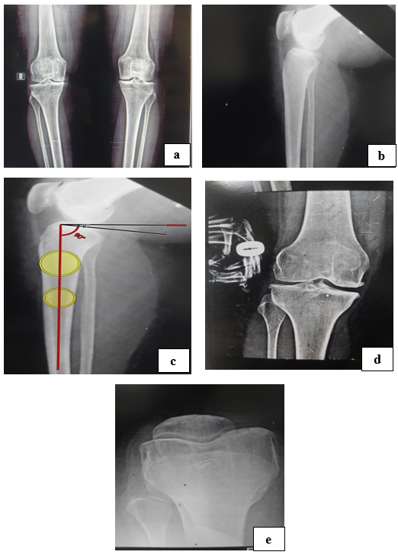
(A)
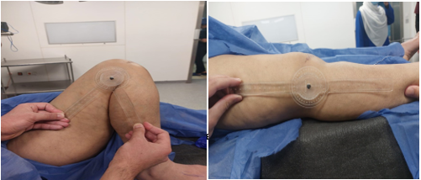
(B)
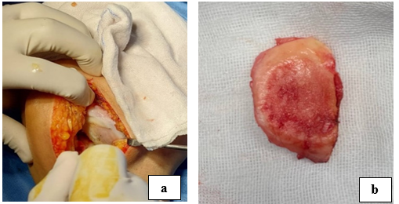
(C)
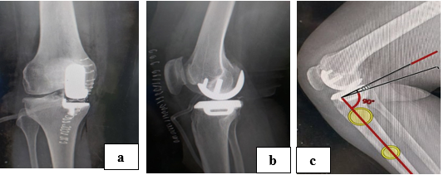
(D)
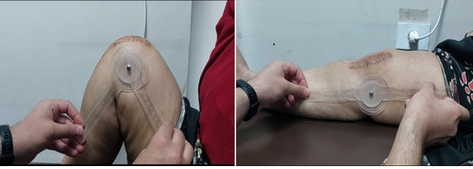
(E)
Figure 1: (A) Pre operative xrays ( a: satanding view, b :lateral view, c: pre opeartive PTS 8 º, d: stress valgus view, e: skyline view), (B): pre operative range of motion, (C): intraoperative findeding (a: eroded medial femoral condyle cartilage, b: anteromedial erosion of medial tiabial platau), (D): postoperative imaging (a: AP view, b: lateral view, c: posterior slope of tibial component 10º), (E): postopeative range of motion
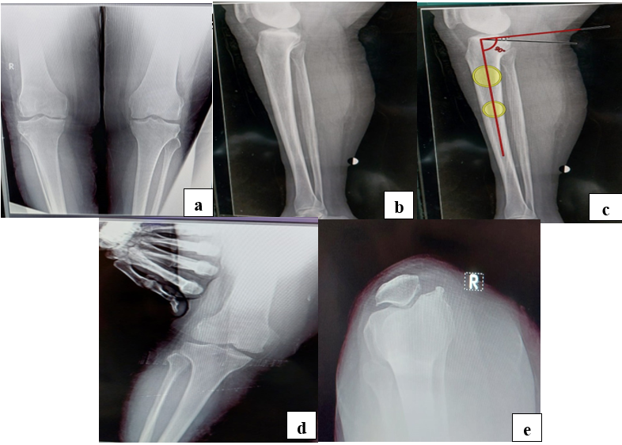
(A)
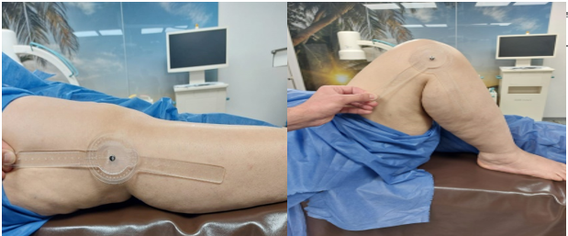
(B)
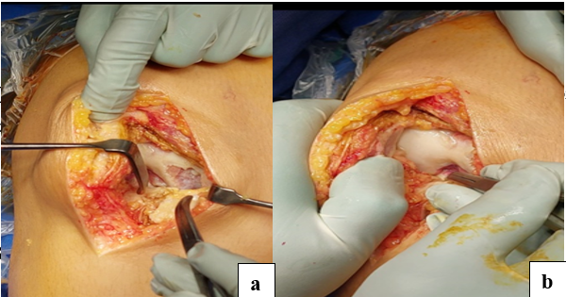
(C)
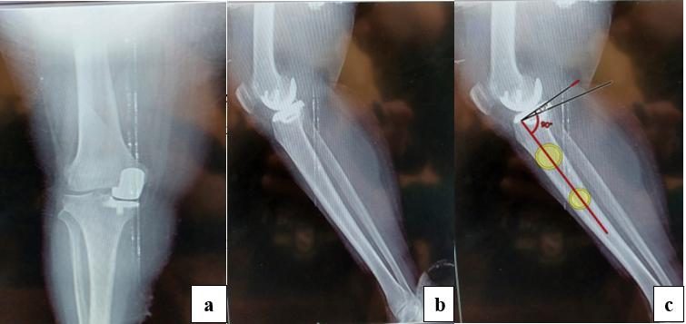
(D)
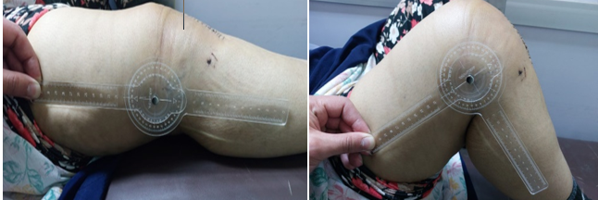
(E)
Figure 2 : (A) pre operative x rays (a: satanding view, b: lateral view, c: pre opeartive PTS 11 º, d: stress valgus view, e: skyline view), (B): pre operative range of motion, (C): intraoperative findeding (a: osteonecrosis of medial femoral condyle , b: intact lateral cartilage ), (E): postoperative imaging (a : AP view , b : lateral view , c: posterior slope of tibial component 12º), (D): postopeative range of motion.
ACL | Anterior cruciate ligament
ASIS | Anterior superior iliac spine
BMI | Body mass index
DM | Diabetes mellitus
HTN | Hypertension
HTO | High tibial osteotomy
IM | Intramedullary
MCL | Medial collateral ligament
MCL | Medial collateral ligament
OA | Osteoarthritis
OKS | Oxford knee score
PTS | Posterior tibial slope
PTS | Posterior tibial slope
ROM | Range of motion
TKA | Total knee arthroplasty
UKA | Unicompartmental knee arthroplasty

